Que 1) Plot a histogram,

10, 13, 18, 22, 27, 32, 38, 40, 45, 51, 56, 57, 88, 90, 92, 94, 99

Answer:

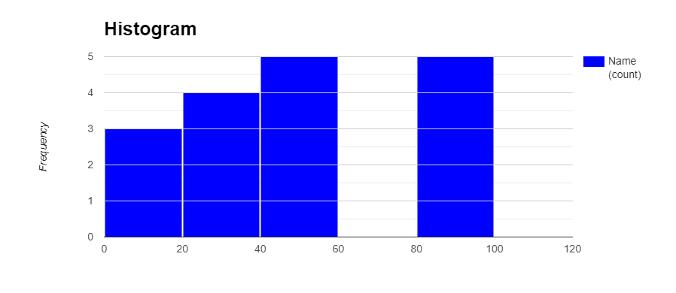

Que 2) In a quant test of the CAT Exam, the population standard deviation is known to be 100. A sample of 25 tests taken has a mean of 520. Construct an 80% CI about the mean.

Answer:

Que 3) A car believes that the percentage of citizens in city ABC that own a vehicle is 60% or less. A sales manager disagrees with this. He conducted a hypothesis testing surveying 250 residents & found that 170 residents responded yes to owning a vehicle.

1. State the null & alternate hypothesis.
2. At a 10% significance level, is there enough evidence to support the idea that vehicle owner in ABC city is 60% or less.

Answer: To construct a confidence interval (CI) for the population mean, given a known population standard deviation, you can use the formula for a z-confidence interval. The formula is:

CI = x̄ ± z \* (σ / √n)

Where:

* x̄ is the sample mean (520 in your case).
* z is the z-score corresponding to the desired confidence level (80% corresponds to a z-score of 1.28 approximately).
* σ is the known population standard deviation (100 in your case).
* n is the sample size (25 in your case).

Substitute the values into the formula:

CI = 520 ± 1.28 \* (100 / √25)

Calculate the values:

CI = 520 ± 1.28 \* 20 CI = 520 ± 25.6

So, the 80% confidence interval about the mean is approximately (494.4, 545.6). This means that we are 80% confident that the true population mean lies between 494.4 and 545.6 based on the sample data.

Null Hypothesis (H0): The percentage of citizens in city ABC that own a vehicle is 60% or less. Alternative Hypothesis (Ha): The percentage of citizens in city ABC that own a vehicle is greater than 60%.

In mathematical terms:

H0: p ≤ 0.60 (where "p" represents the true proportion of vehicle owners) Ha: p > 0.60

Here, the null hypothesis assumes that the car's belief is correct (percentage ≤ 60%), while the alternative hypothesis suggests that the car's belief is incorrect (percentage > 60%).

To determine whether there is enough evidence to support the idea that vehicle ownership in ABC city is 60% or less, you would perform a hypothesis test at a 10% significance level. This means that you're willing to tolerate a 10% chance of making a Type I error (rejecting a true null hypothesis).

In practical terms, you would calculate the test statistic (such as a z-test or t-test, depending on the sample size and assumptions) and the corresponding p-value based on the sample data (250 residents surveyed, 170 responded yes to owning a vehicle).

If the calculated p-value is less than or equal to 0.10 (the significance level), then you would reject the null hypothesis in favor of the alternative hypothesis. This would imply that there is enough evidence to suggest that the percentage of vehicle owners in city ABC is indeed greater than 60%.

If the calculated p-value is greater than 0.10, then you would fail to reject the null hypothesis, indicating that there isn't enough evidence to support the idea that the vehicle ownership percentage is greater than 60%.

Que 4) What is the value of the 99 percentile?

2,2,3,4,5,5,5,6,7,8,8,8,8,8,9,9,10,11,11,12

Answer: The 99th Percentile is 11.81

Que 5) In left & right-skewed data, what is the relationship between mean, median & mode?

Draw the graph to represent the same.

*Answer: In left-skewed (negatively skewed) data, the mean is typically less than the median, which is less than the mode. This is because the tail of the distribution is extended towards the left side, pulling the mean in that direction. The mode is often the highest point in the distribution.*

*In right-skewed (positively skewed) data, the mode is often less than the median, which is less than the mean. This is because the tail of the distribution is extended towards the right side, pulling the mean in that direction. The mode is again often the highest point in the distribution.*

*Here's how the relationships among mean, median, and mode look graphically for left-skewed and right-skewed data:*

*Left-Skewed Data:*

*